Clayton Blocks Data Notes – 10/27/2022

HOBO Data (Feb 2021 – Present)
- Data adjusted to depth below soil surface using manual measurements provided at each download
- Barometric data from 4/7/22 – 5/19/22 was missing – possibly a logger or shuttle error. Barometric data for this time frame was obtained from the Tidewater Research Station in Plymouth, NC (https://econet.climate.ncsu.edu/stations/plym/) and used to calculate sensor depth
- Sensor readings indicating hobo loggers were above the water table were removed from the dataset. This included a few single instances during data downloads and one prolonged block from October to December 2021 where the water table in the D16 reference block appeared to drop below the bottom of the well.
In-Situ Data (October 2015 – Present)
- Data adjusted to depth from soil surface using values provided in “Clayton Blocks In-Situ Logger Specs” file
- Data from well D16 2A is missing from 8/26/21 to 4/7/22. Is there another data file somewhere?
- The C14 A and B wells appear to have some periods of error where the data jumps up and down rapidly by a few feet for a few weeks to a few months at a time (see example graph below). The data between these periods seems normal compared to the other loggers, so I’m not sure what is causing them to go wrong only during certain times. Maybe something is interfering with the atmospheric pressure connection? For now, I’ve just cut these instances out of the dataset as errors. Most of the time only one of the two C14 loggers has bad data, but there’s a period from February to April 2018 where both are wrong, leaving no data for the C14 block at that time.
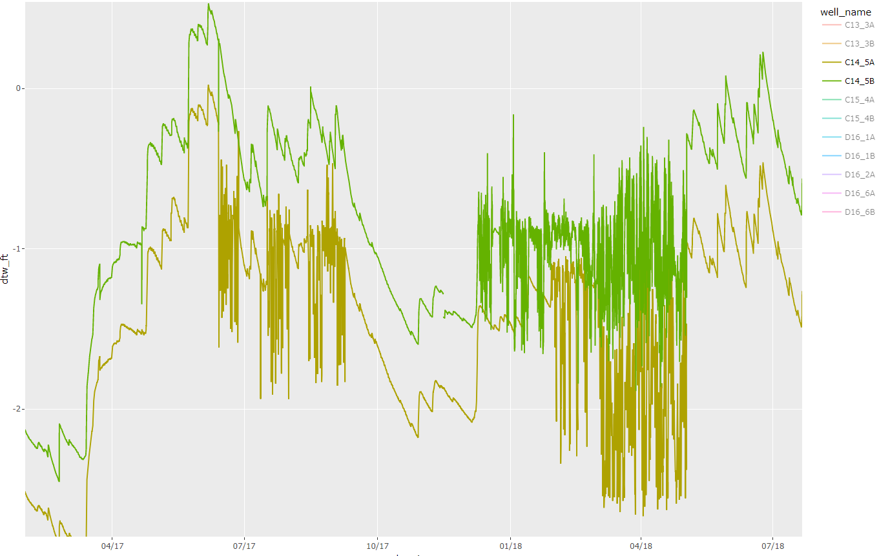
- Starting in 2019, some of the data shifted from logging on the hour mark to a specific minute. To make each dataset more comparable, I’ve aggregated everything by hour (so data downloaded at 1:16 will show as 1:00, etc.). Since each data log is already a single snapshot representing the entire hour I thought this would be fine, but if you’d rather preserve the original download times I can change that back. It would just mean a separate data table for each well, rather than combining the data into a single table.

For both in-situ and hobo wells, I’ve arranged the data so that negative values represent the water table below the surface and positive values are above ground. I can flip this if you’d prefer. I’ve also converted the in-situ values to feet, but I can keep them in meters if you’d rather do that as well.

